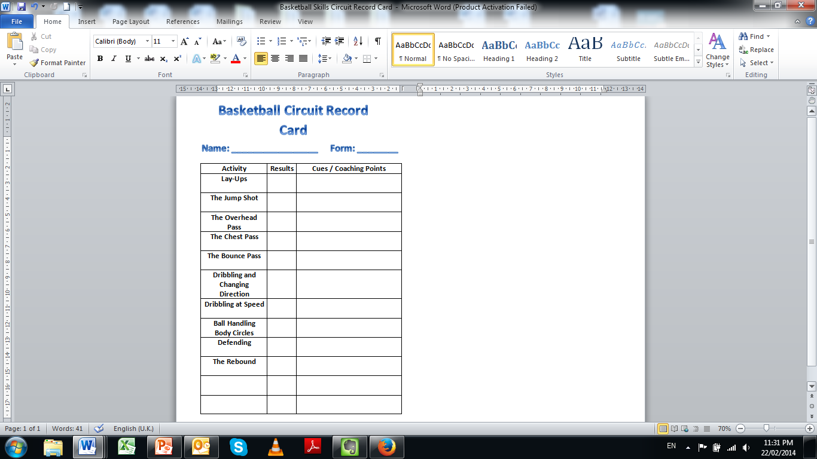

**Basketball Circuit Record Card**

**Name: _________________ Form: ________**

|  |  |  |
| --- | --- | --- |
| **Activity** | **Results** | **Cues / Coaching Points** |
| **Lay-Ups** |  |  |
| **The Jump Shot** |  |  |
| **The Overhead Pass** |  |  |
| **The Chest Pass** |  |  |
| **The Bounce Pass** |  |  |
| **Dribbling and Changing Direction** |  |  |
| **Dribbling at Speed** |  |  |
| **Ball Handling Body Circles** |  |  |
| **Defending** |  |  |
| **The Rebound** |  |  |
|  |  |  |
|  |  |  |

**What activity did you find the most challenging and why do you think this was?**

**What activity did you find the most challenging and why do you think this was?**

**You next lesson will look at dribbling and ball control, what is your S.M.A.R.T target for this lesson?**

**How do you aim to improve in this activity during the unit?**

**You next lesson will look at dribbling and ball control, what is your S.M.A.R.T target for this lesson?**

**How do you aim to improve in this activity during the unit?**